48730 Cyber Security — Lab 1(Week 1&2)

48730 / 32548 Cyber Security — Lab 1 (Week 1 & 2)
Student name: | Jinkyung Kim
Student ID: | 14657314
Date: | 12 August 2026

Task 1 — Sniff Login Details from Unencrypted HTTP Traffic
Wireshark captured (wifi promiscous mode) traffic when login credentials were sent to http://bias.csr. uni.bo.it/fvc2004/logon.asp over http. Capture filtered with display filter frame contains "POST".
Question: Provide a screenshot of the username and password credentials used in Wireshark.
Answer: Because the site uses unencrypted HTTP, the login credentials are transmitted in clear text inside the HTTP POST body (HTML Form URL Encoded). The captured form items id and pwd are fully readable, as shown below. 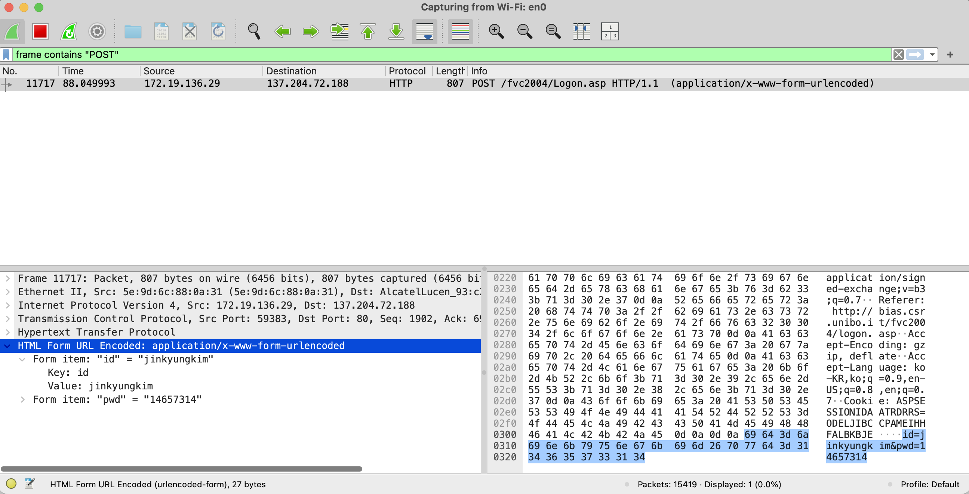
Fig 1. POST /fvc2004/Logon.asp — id = "jinkyungkim", pwd = "14657314" captured in clear text.
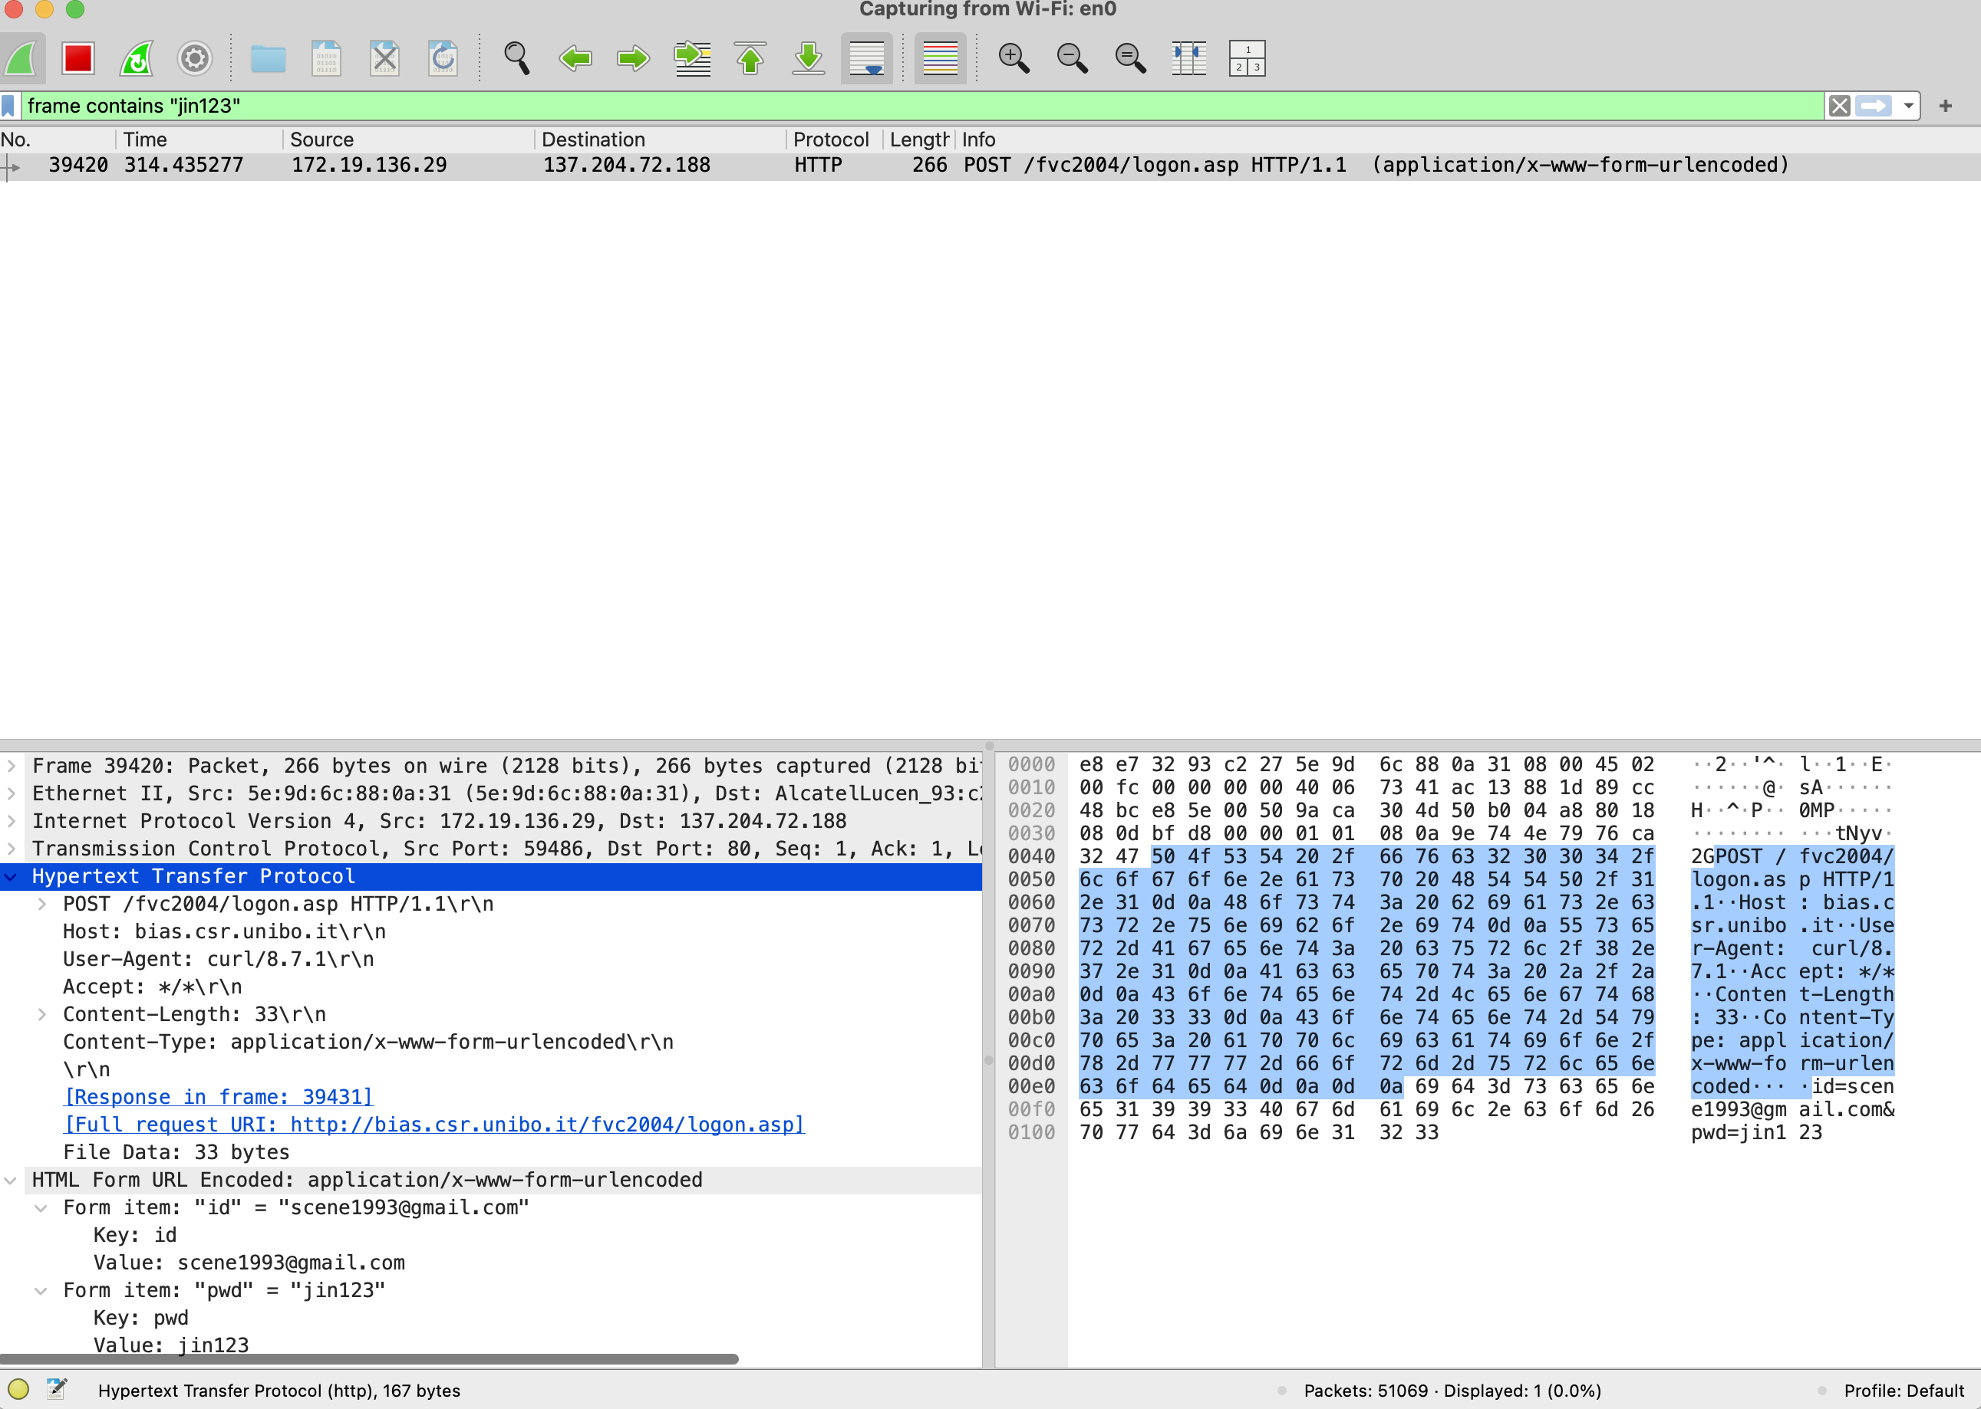
Fig 2. A second POST — id = "scene1993@gmail.com", pwd = "jin123" visible in plaintext.

Task 2 — Extract an Image from an Unencrypted HTTP Packet
Located GET packets with the same capture and exported objects through File > Export Objects > HTTP.
Question: Take a screenshot of the list of HTTP objects containing the list of images we got from the webpage.
Answer: The HTTP object list shows the image files served by bias.csr.unibo.it, including bullet.gif and fvc2004_head.gif (Content-Type image/gif), which can be extracted with Save. 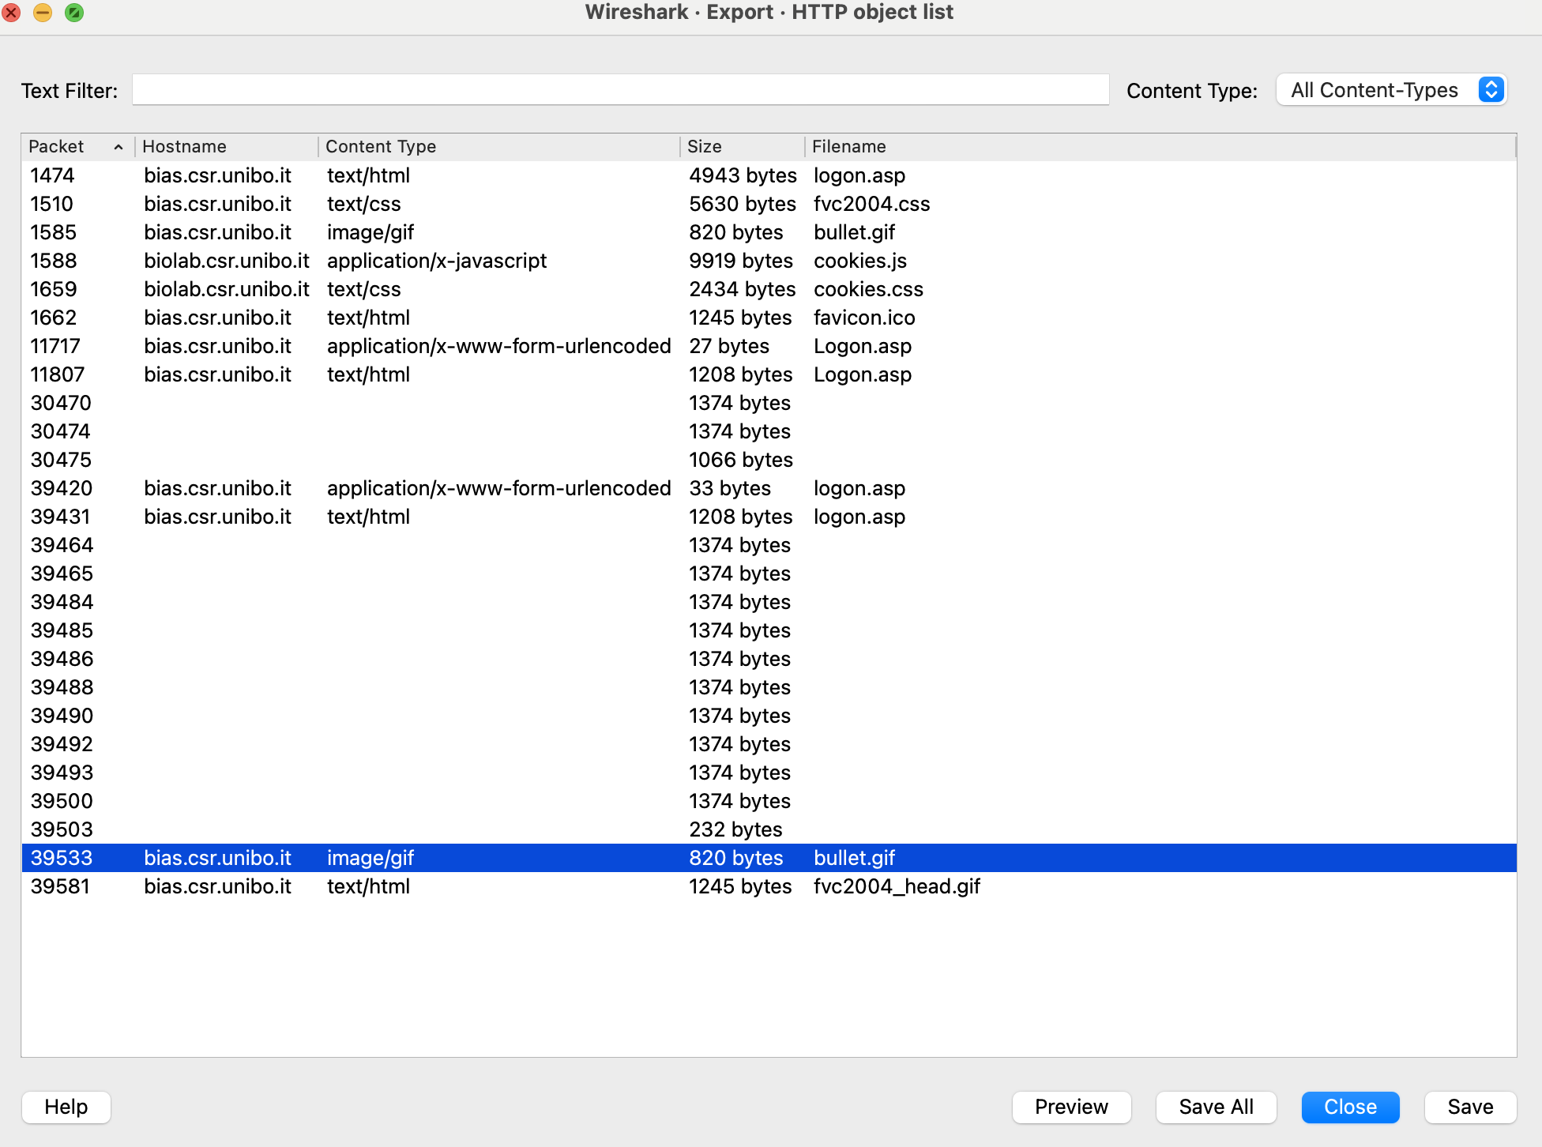
Fig 3. HTTP object list — bullet.gif selected (image/gif, 820 bytes).
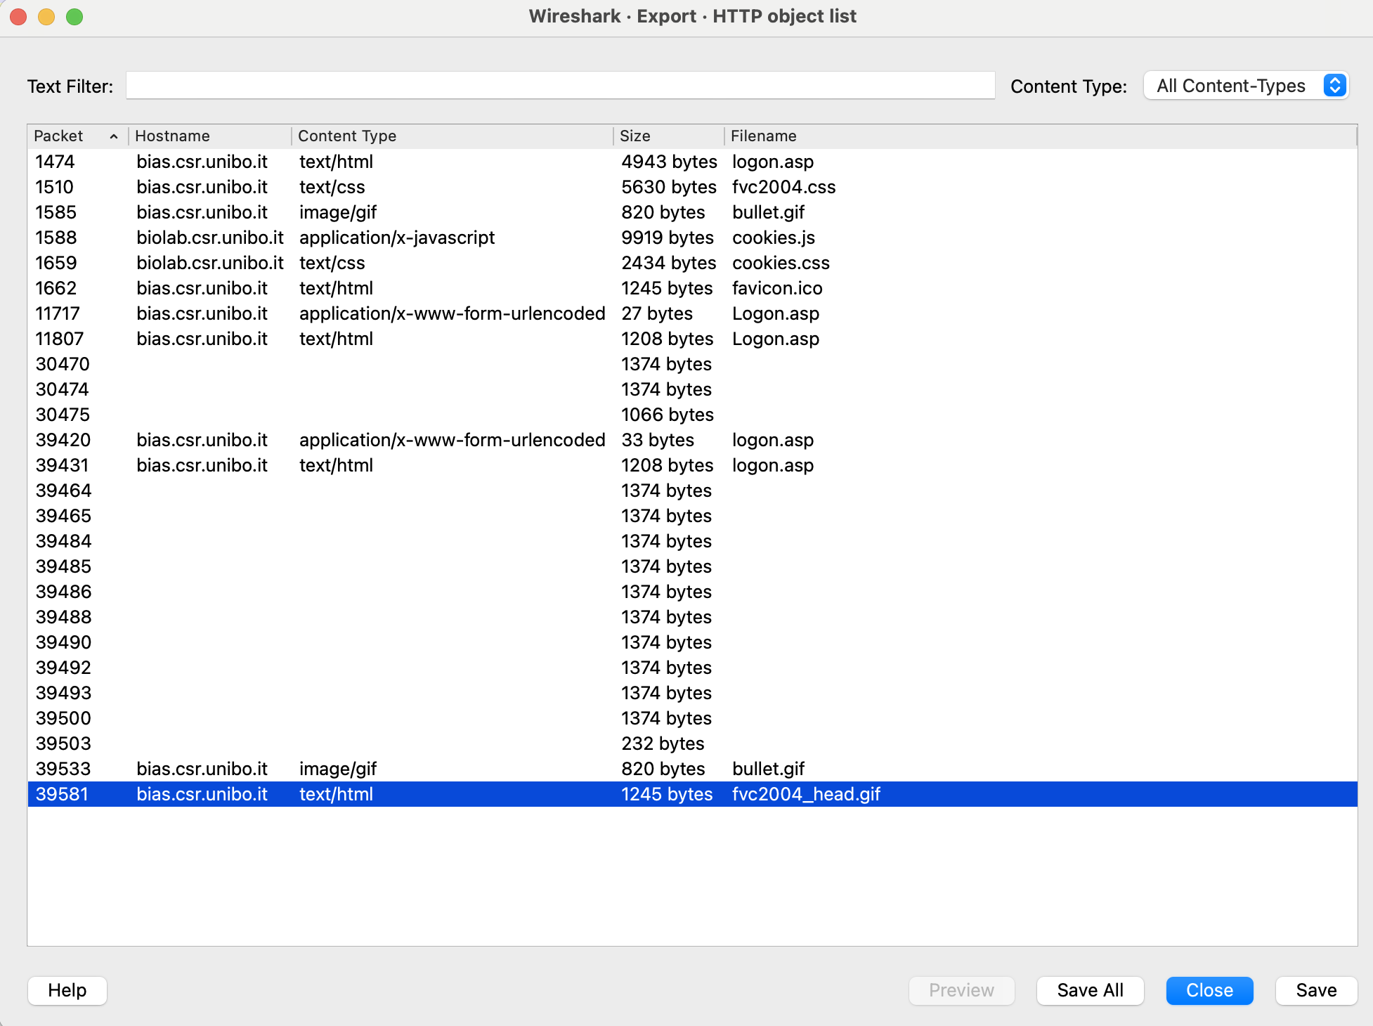
Fig 4. HTTP object list — fvc2004_head.gif selected.

Task 3 — Information Gathering (target: www.uts.edu.au)
Netcraft Site Report (sitereport.netcraft.com) was used to gather information about www.uts.edu.au.
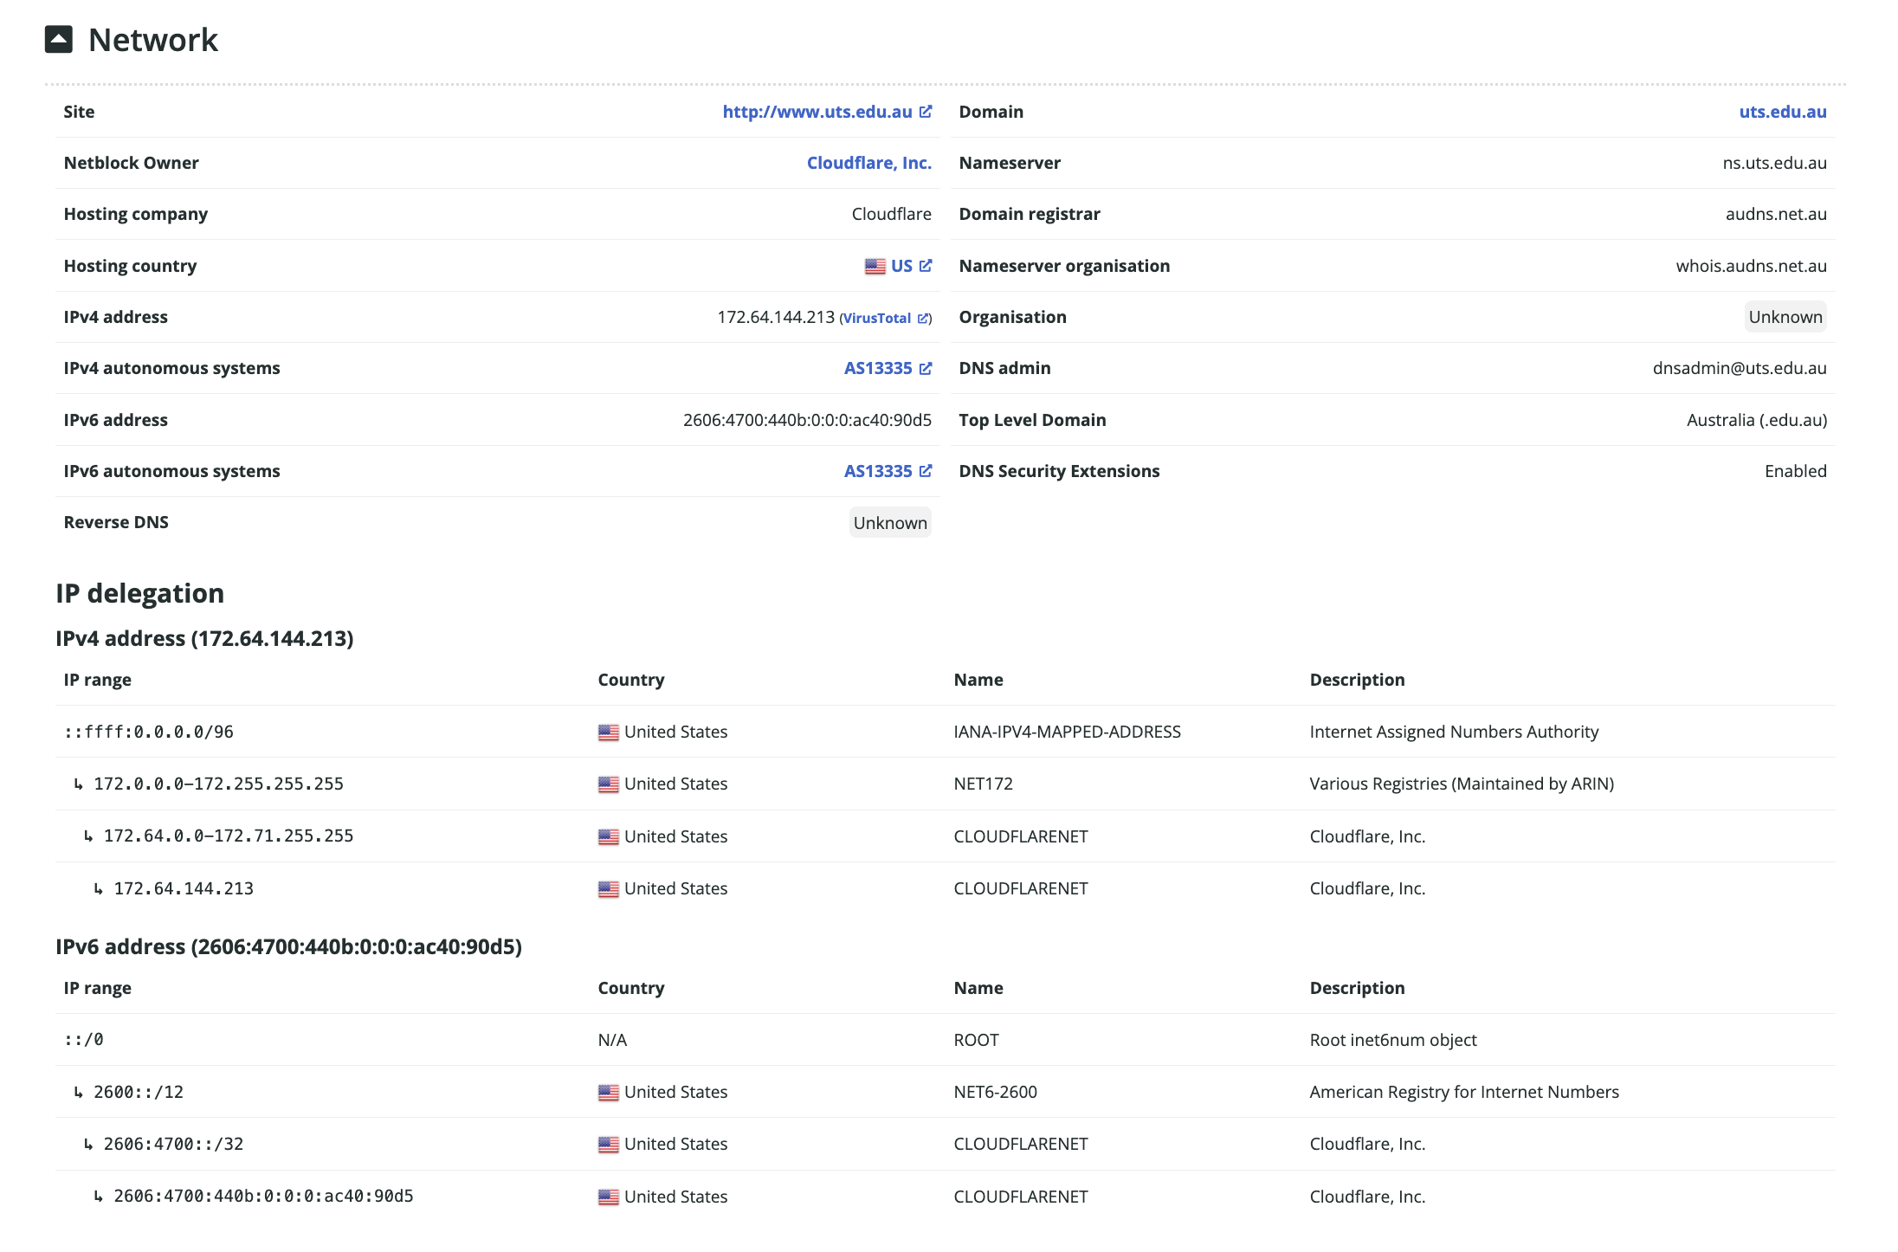
Fig 5. Netcraft site report for www.uts.edu.au.
- IP address: 172.64.144.213 (IPv6: 2606:4700:440b::ac40:90d5)
- Type the IP in the browser — observations: The UTS site does not load directly; a Cloudflare error / default page appears, because 172.64.144.213 is a Cloudflare proxy IP that routes by Host header/SNI, so the real origin is hidden.
- IP owner (Netblock owner): Cloudflare, Inc.
- Server operating system: Not disclosed — hidden behind the Cloudflare proxy.
- Web server type: Cloudflare (nginx front-end).
- Server-side scripting technology: Not disclosed (masked by Cloudflare).
- Domain admin email (possible phishing): dnsadmin@uts.edu.au
- Reverse DNS: Unknown.
- Domain registrar: audns.net.au
- Nameserver organisation: whois.audns.net.au (Nameserver: ns.uts.edu.au)
- Hosting company: Cloudflare
- Hosting company location: United States (US)

Task 4 — Password Cracking using John the Ripper
On the Cybersec-Server, the mypasswd file (username + hashed password) was cracked using single, wordlist and rules modes.
cd ~/Documents john --show mypasswd # 0 cracked (before) john mypasswd # single mode john --wordlist=password.lst mypasswd # wordlist mode john --wordlist=password.lst --rules mypasswd # mangling rules john --show mypasswd # final result 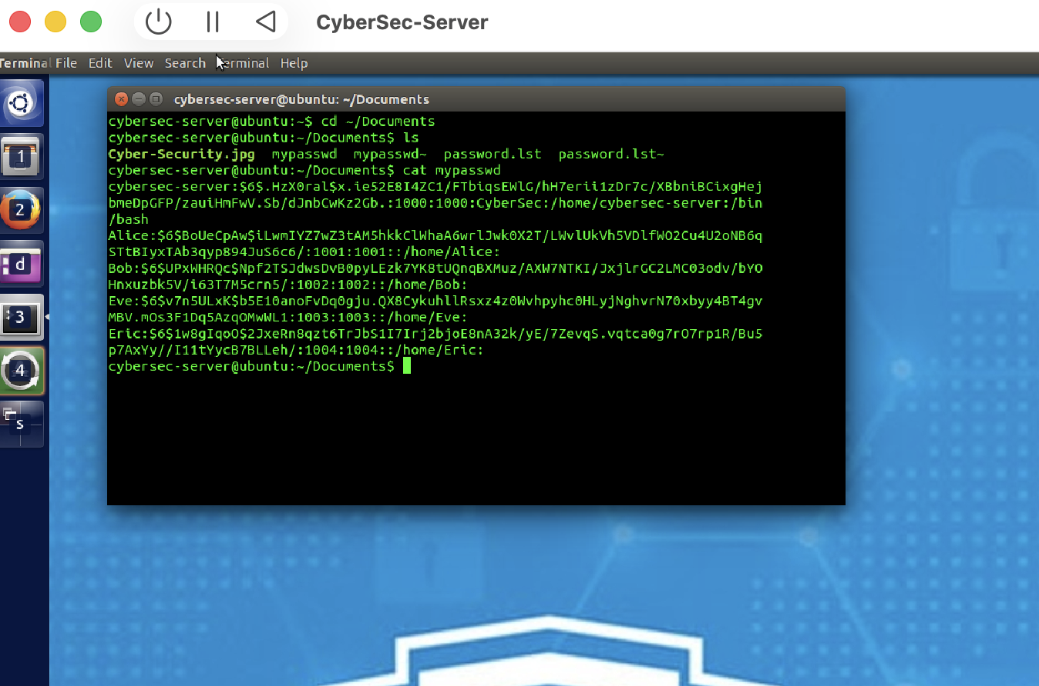
Fig 6. Contents of mypasswd (hashed passwords).
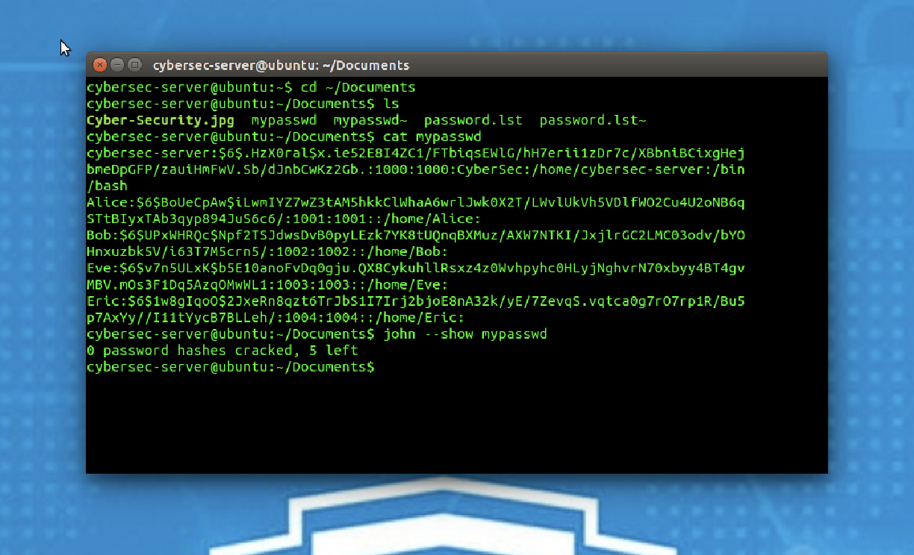
Fig 7. john --show before cracking: 0 cracked, 5 left.
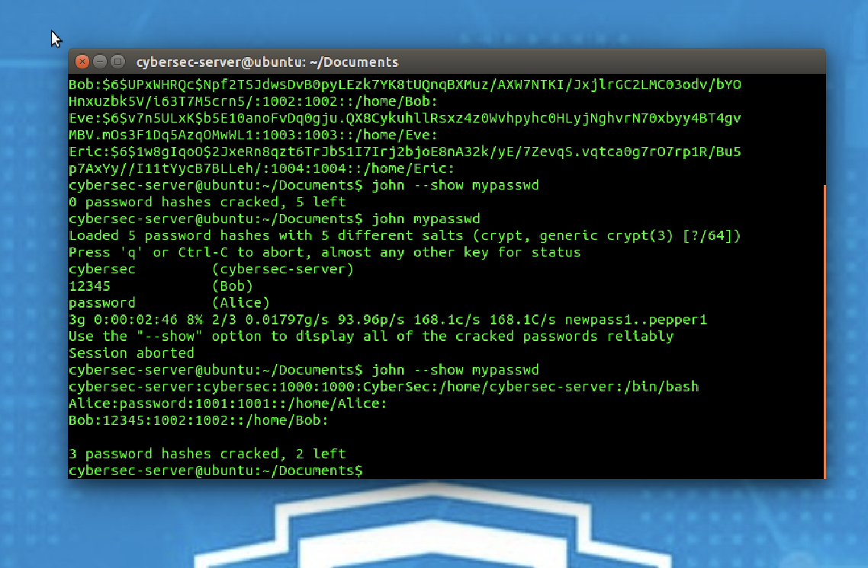
Fig 8. Single mode cracks cybersec-server, Bob, Alice → 3 cracked.
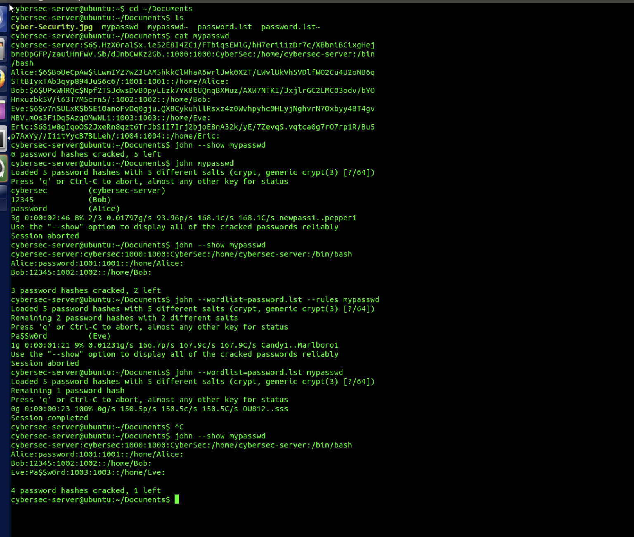
Fig 9. After wordlist + rules: cybersec, Alice=password, Bob=12345, Eve=Pa$$w0rd (4 cracked, 1 left).
Cracked passwords: cybersec-server = cybersec, Alice = password, Bob = 12345, Eve = Pa$$w0rd.
Challenge 1: Cracking Eric’s password
Answer: Unable to crack Eric's password using single, wordlist or rules modes in a reasonable time frame. Eric used a good password that wasn't found in the dictionary and that can't be cracked with mangling rules (only an exhaustive brute-force / incremental attack would discover it).
Challenge 2: How to secure the password
Answer: Weak, short or dictionary-based passwords (e.g. password, 12345) are cracked almost instantly, while a password that is not in any wordlist (Eric's) survives. A secure password should be long (12+ characters), mix upper/lower case, numbers and symbols, avoid dictionary words and personal information, and be unique per account.

Task 5 — SQL Injection (login bypass at http://localhost/)
The login form builds the query SELECT username,password FROM members WHERE username='$u' AND password='$p', with no input sanitisation, so it is vulnerable to SQL injection.

I. Username = 123456789, Password = SQL command
Username: 123456789 Password: ' OR '1'='1 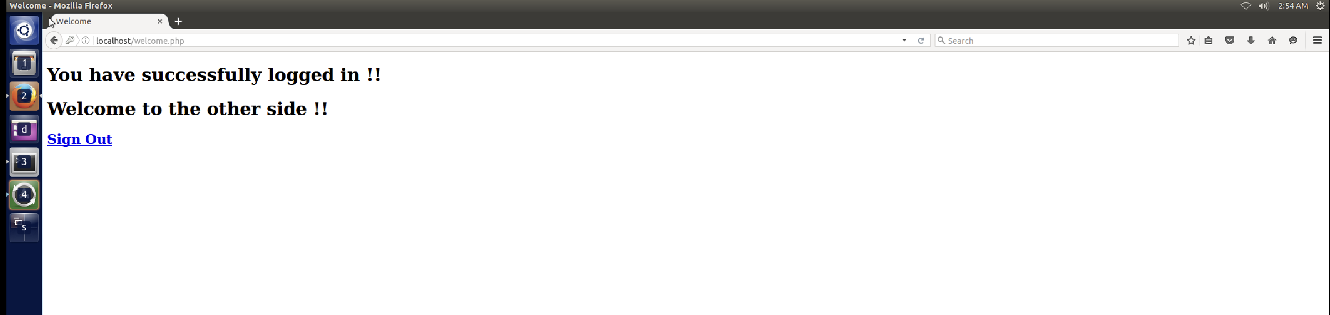
Fig 10. Login bypassed — "You have successfully logged in".

II. Both Username and Password as SQL commands
Username: ' OR '1'='1 Password: ' OR '1'='1 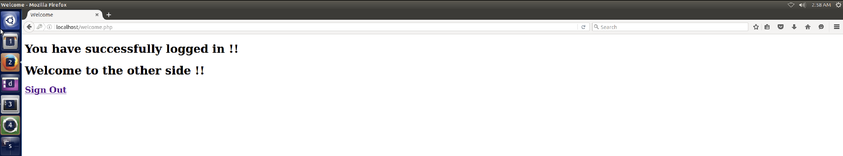
Fig 11. Login bypassed with injection in both fields.
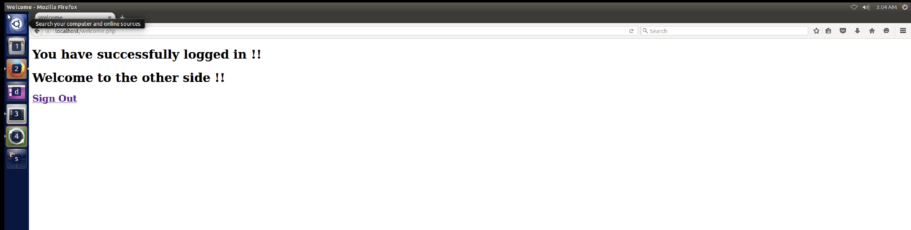
Fig 12. Additional successful bypass.
Q1: Provide screenshots and mention the SQL commands used to gain unauthorized access.
Answer: The payload ' OR '1'='1 makes the WHERE clause always true, so the query returns rows and authentication is bypassed (see Figs 10–12). The commands used are listed under each sub-task above.
Note: Sub-tasks III (dumping all usernames/passwords) and IV (logging in as a specific extracted user) rely on the application echoing query data. The welcome page only prints a static "successfully logged in" message and does not display returned rows, so login-bypass injection was demonstrated successfully (I & II); full data extraction was not displayed by the application.
Q2: Based on your observations, suggest a defence.
Answer: Use parameterized queries / prepared statements so user input is never concatenated into SQL; validate and sanitise all input; apply least-privilege database accounts; disable detailed SQL error messages to the client; and use a web application firewall (WAF).

Task 6 — Port Scanning (aggressive scan from Cybersec-Attacker)
Q1: Run an aggressive port scan on cybersec-server (10.0.2.6) and cybersec-client (10.0.2.8) from cybersec-attacker. Provide screenshots of the port scan report.
sudo nmap -A 10.0.2.6 # cybersec-server sudo nmap -A 10.0.2.8 # cybersec-client
Answer: Both hosts show the same open services: 21/tcp ftp (vsftpd 3.0.2), 22/tcp ssh (OpenSSH), 23/tcp telnet, 53/tcp domain (BIND 9.9.5), 80/tcp http (Apache 2.4.7). OS/service detection identifies a Linux (Ubuntu) host. 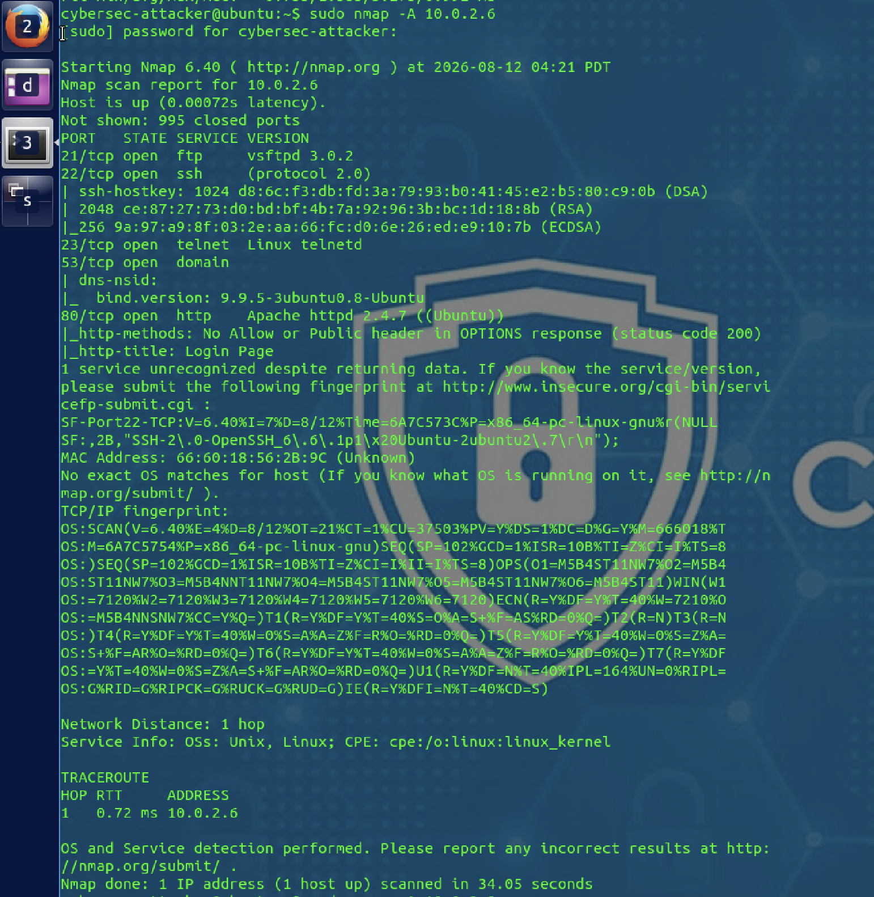
Fig 13. Aggressive scan of cybersec-server (10.0.2.6).
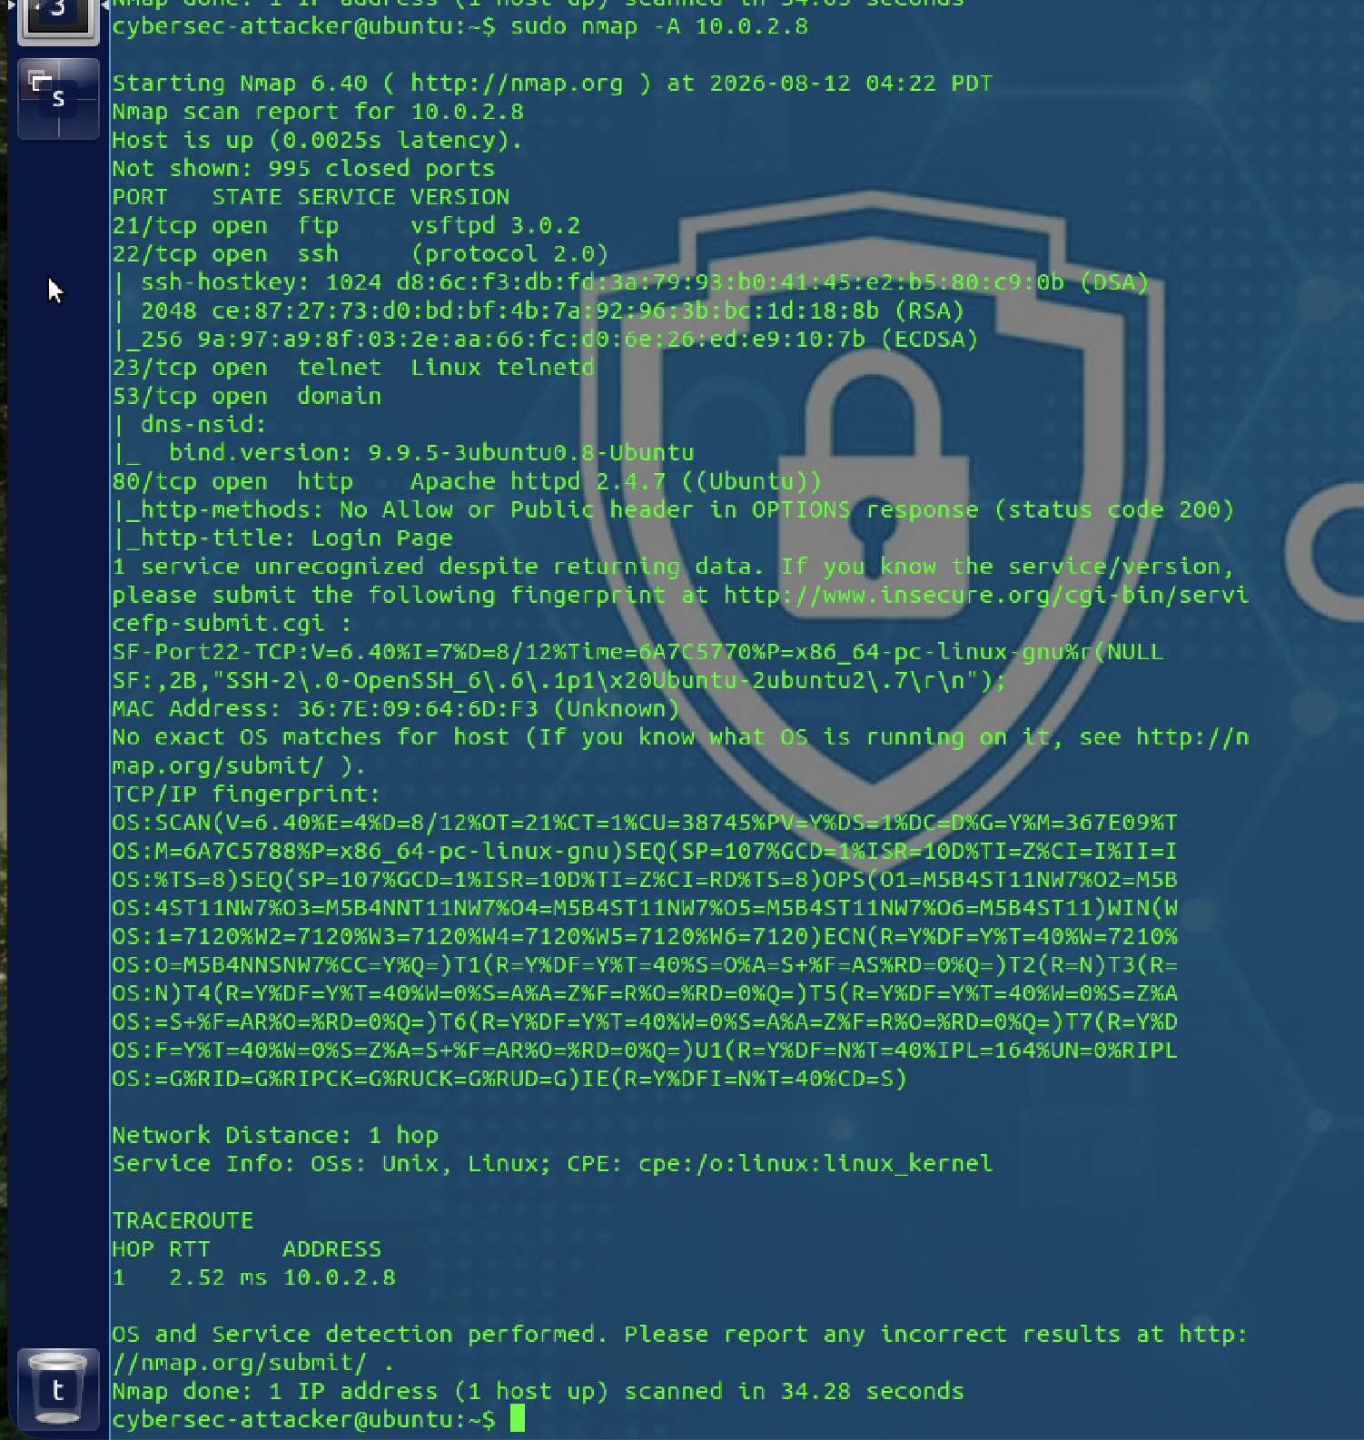
Fig 14. Aggressive scan of cybersec-client (10.0.2.8).

